**PRE-REQUISITES Team ID : PNT2022TMID45469**

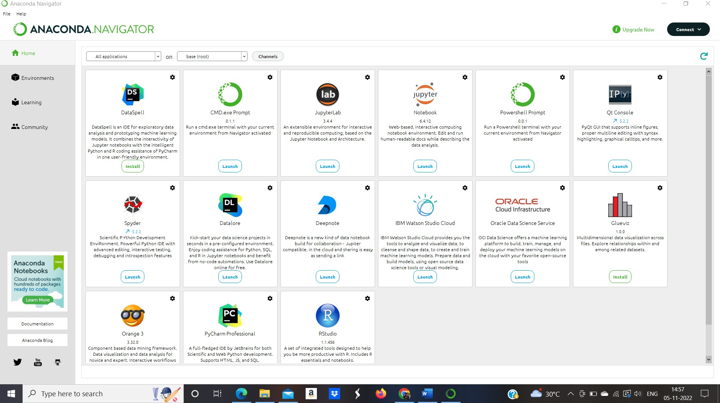

If you are using anaconda navigator, follow the below steps to download the required packages:

* Open anaconda prompt as administrator.
* Type **"pip install tensorflow==1.14.0”** and click enter.
* Type **"pip install keras=2.2.4”** and click enter.
* Type **"pip install opencv-python”** and click enter.
* Type **“pip install imutils”** and click enter.
* Type **"pip install flask”** and click enter.

